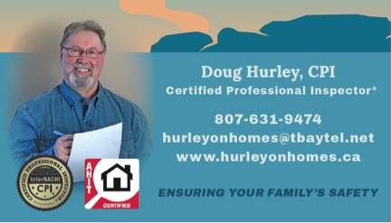
A Home Inspection is a very important part of buying or selling a home, a job I do not take lightly. I be honored to be part of your team.
I would like to take a moment to introduce my Home Inspection Business to you. My name is Doug Hurley, the owner/inspector of HurleyonHomes Property Inspections. I am a member of the Thunder Bay Real Estate Board and carry Liability and E&O insurance. I offer each client an ethical complete home inspection with electronic or hard copy reports done in a computer generated comprehensive, narrative report complete with documented pictures. I use testing equipment such as a gas detector, heat gun, and moisture meter to name a few. I respect the Sellers property by wearing inside shoes only, use a drop sheet when checking the attic, and carry a small vacuum to clean up any mess. I will be charging $350.00 inclusive per inspection in the city limits, cost outside the city limits (with-in a 4 hour drive) vary with travel time @$25.00 per hour and distance @ .40 cents per km. Clients, with their consent, will also receive the InterNachi Homeowner Newsletter, which is customized according to condition of each house inspected and has 5 years worth of monthly issues.
My working career consisted of been a Journeyman Millwright, Supervisor, Health and Safety Officer, Production Manager, and home renovator. I have completed a 300 hours home inspector course with the American Home Inspector Training Institute (AHIT) and I am a member of The International Association of Certified Home inspectors (InterNachi). I adhere to the Standards of Practice and the Code of Ethics for Home Inspectors in the province of Ontario.
I had to pass NACHI's Online Inspector Examination.
I have to continue learning 90 hours this year and (24 hours/year) as per NACHI's Continuing Education Policy.
I had to submit 4 mock inspections to NACHI's Report Review Committee before performing my first home inspection for a client, which I completed.
Have to complete NACHI's comprehensive online Roofing course and I have to re-take and pass NACHI's Online Inspector Examination, every year. But by being a member of InterNachi I can offer potential homebuyers a “We’ll Buy Back Your Home Guarantee” Honored for 90 days after closing if the participating InterNachi Inspector misses anything. More info can be found at www.nachi.org/buy.
InterNachi is so certain of the integrity of their members
they back them up with our $10,000 Honor Guarantee Protecting seller’s property from the member's taking of the personal property.
InterNachi is so sure of its inspectors that it will
Indemnify any licensed real estate agent in an amount up
to $10,000 if a third party successfully sues the agent for
negligent referral of an InterNachi inspector. This
protection is offered at no cost to agents who
register. www.nachi.org/agent-indemnification.htm

Thank you for your time,

Doug Hurley CPI

